**Course Project –** [**Audience Perceptions**](https://learning.rasmussen.edu/webapps/assignment/uploadAssignment?content_id=_6076865_1&course_id=_67422_1&group_id=&mode=view)

Shaun Pritchard

Rasmussen College

QMB3300

Jerome Olorunmaiye

June 04, 2020

**Course Project –** [**Audience Perceptions**](https://learning.rasmussen.edu/webapps/assignment/uploadAssignment?content_id=_6076865_1&course_id=_67422_1&group_id=&mode=view)

I am developing a study on energy consumption to increase public awareness of the cost of electricity throughout the United States. Particularly the study for my intended audience in my home state of Florida. Since this is to create public awareness there going to be multiple types of audiences that I am going to have to cater to and relay the valuable attributes of data through visualization.

With audiences, we can personify them they are different categories and types. Which can all be based on the specific intensive values of the data being visually portrayed. Here are a few of the different audience types that can be categorized for public awareness *(fppt, 2020).*

* **Neutral Audiences** consist of the kind of people who are directly or indirectly interested or do not want to invest in ideas being portrayed through the data.
* **Hostile Audiences**are the people who are in strong disagreement with our premise or the premise concerning the subject.
* **Uninformed Audiences** are people who are unfamiliar with the topic of discussion at hand.
* **Expert Audience** is people who are in-tangent with what you are telling them so the biggest mistake you can do is to give them a background of the topic.
* **Business Audience** is more adaptive to the bottom line. Time is money for this audience, and they do not have the patience to sit through your storytelling .

The intent of each audience is specific, but all audiences have 3 stages of intent specific to how they consume data. These stages are as follows *(SmartBug, 2019)*.

* **Awareness -**realizing a need for the premise of the**ar**gument in our data visualization.
* **Consideration -**about an audience's evaluation of different methods that are available to them.
* **Decision -**at this point, an audience has decided on a solution or agrees with the premise.

These stages of intent help to define the overall purpose of the data and visualization we are trying to create. We can methodically use visualizations to take our data from the purpose of awareness. To actively getting people involved in considering the validity and the premise of our goals. In this case, showing the audience the factors of energy consumption. Considerations from awareness can help people be more self-conscious and make decisions to use different sources, watch their consumption, and advocated policy or spending to incorporate more sustainable solutions.

Audiences that may benefit from the study the most would be the uninformed audience or the neutral audience. Since we are using data to create a visual story and relay message information in consideration of public awareness. Those who do not know the knowledge would gain more benefit from learning about it. If the visualization and data are compelling enough. It could facilitate in persuading the Hostile audience into agreeing with the premise.

Regardless, to cater to all of these types of audiences we need to be specific in using the data to design a visualization that will be aligned with a common list of all the preferences of our audience type. The main thing we should focus on is the audience's attention, time, aesthetics, punctuality, and approximation while strategically using preattentive attributes *(Knaflic, 2015)*.

These will highlight specifics, use tools, and visually save the audience time while making subconscious connections to keep them engaged.

Things we would need to be aware of while creating a visualization is emphasized in the simplicity and cleanliness of the story we are telling. We need to be conscious of being recursive with the same data points in the storyline. Using Aesthetics within specific color guidelines(visually pleasing) and being as simple as we possibly can and telling the story while portraying the biggest impact. In a way that can be concerned very quickly without repetitive distraction.

To visualize the awareness of consumption in the State of Florida, for instance, We want to visually show diagrams graphics that would display show the different sources of energy consumption, the amount of energy consumption, use-charts to rank, expenditures, and production the prices using other graphics to relay the story and effect of our state's energy consumption and sustainability on an environmental level.

The first visualization from the state energy portal that depicts the state profile of energy consumption for the state of Florida. The map uses a grey base layout for the state of Florida using many different icons to display the different types of power plants both renewable, non-renewable, and sustainable. It also gives us a block chart of Florida's U.S rankings to show consumption categories such as expenditures, production, prices, and environmental ranking score based on the total energy consumption per capita. It also shows quick facts below that summarize very important points based on energy consumption and estimates based on the types of power sources and generation for the state as depicted below.

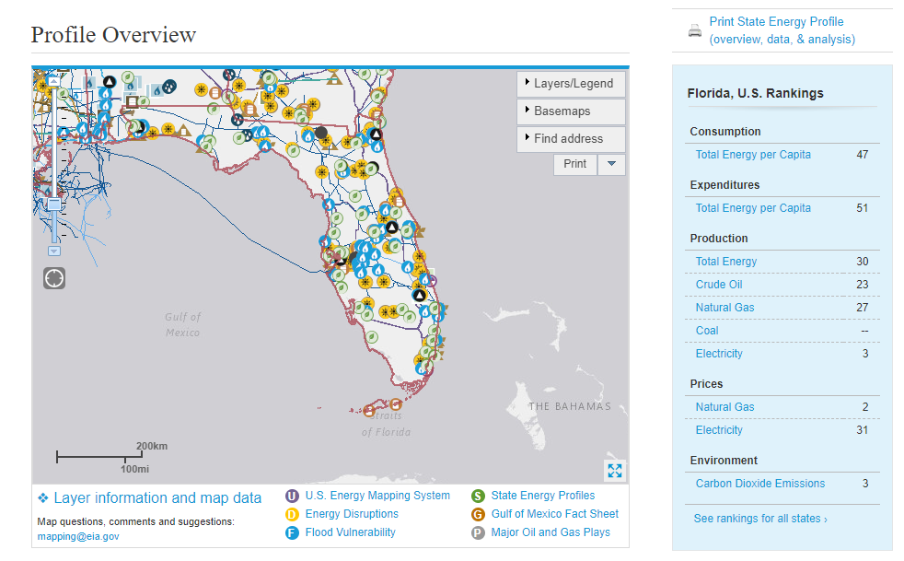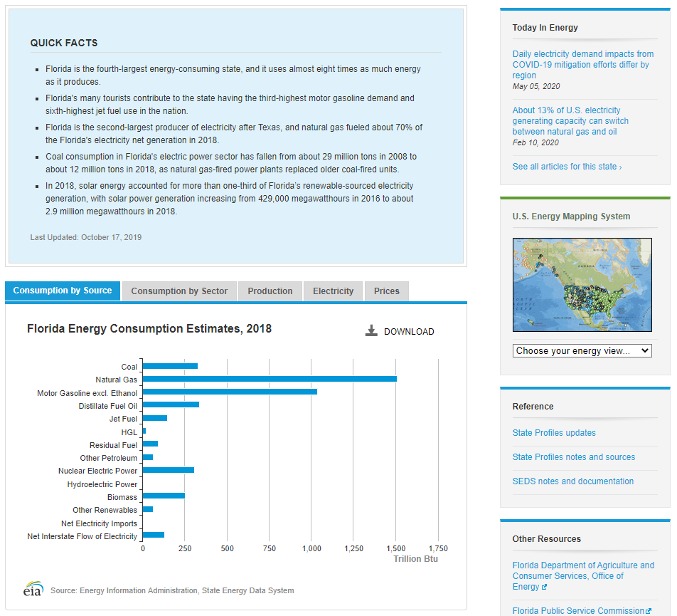

**County and congressional district boundary:**

This map below includes county boundaries and a congressional district of Florida. My district being district 14 in Hillsborough county.

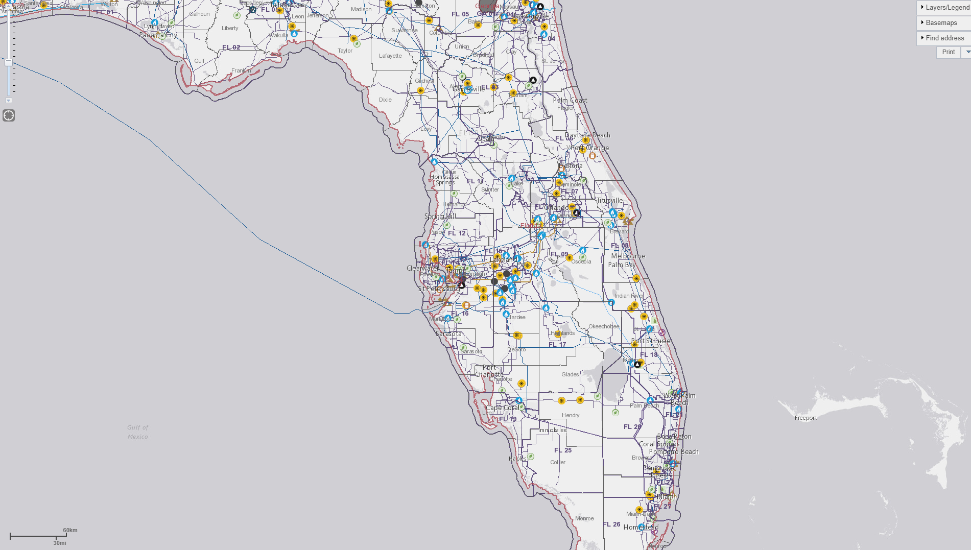

**Solar power Satellite boundary**

This next view shows the solar power boundary view with the base map as a satellite. To show all the different solar distribution stations in Florida. Over the past five years, they have seen personally how they have been incorporating more solar power stations. Especially in my local area of Tampa and Sarasota.

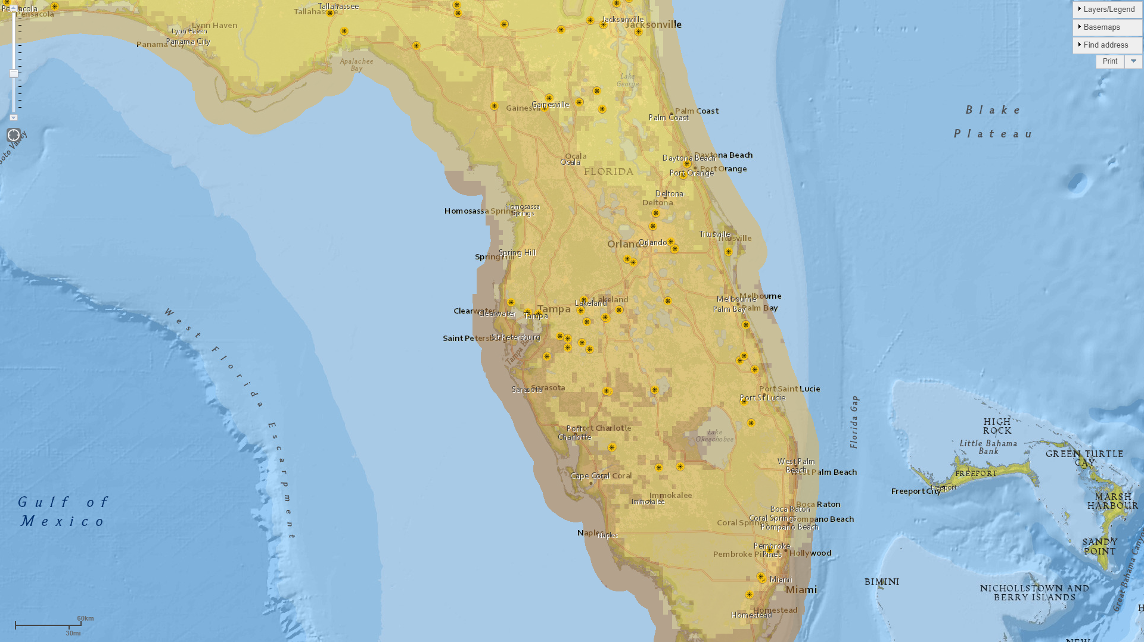

The quick facts table gives us both qualitative and quantitative data best that provide good metrics. The best metric is shown below that in the consumption sources chart tabs. Which breaks down the types of sources, gives estimates, consumption by sector, production, electricity, and prices of power generation and consumption.

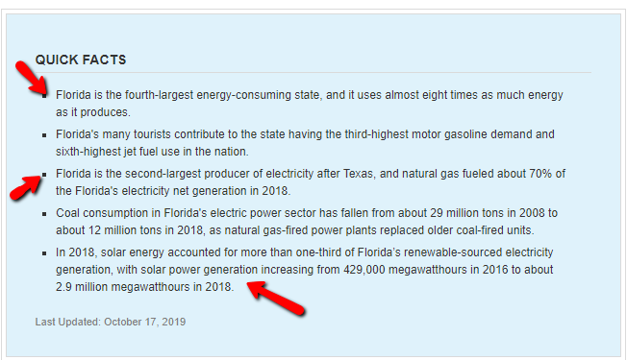

Metrics for understanding the entire State rankings as compared to other states in the country. This data shows that Florida is the fourth largest energy-consuming state and uses almost eight times more energy than it produces. The metrics show that natural gas and motor gasoline are the most consumed resources. where other types of enable sources are not even being used.

The consumption by sector shows the pie chart diving up residential, commercial, industrial, and transportation consumption. This data shows us that if Florida where to Mabey incorporate alternative renewable sources it could reduce Residential and transportation consumption.

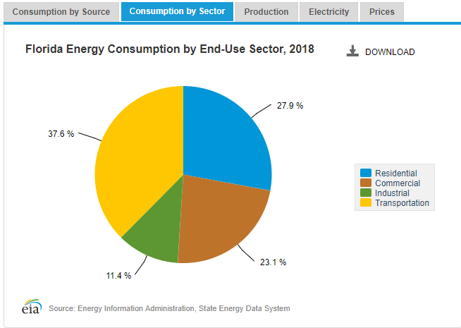

These sections above give more detail into brining awareness to the public based on consumption. For quick stats on rankings metrics alone the chart graph next to the map display ranking info. Though this is a quick refence it lacks detail provided by the other sections.

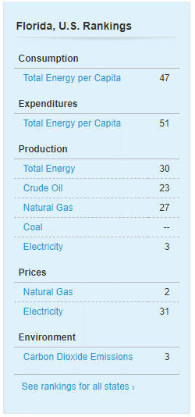

The map itself is customizable and can distribute quick visualization of multiple or individual stations, power plants, refining, production, natural gas pipelines, transportation, fossil resources, and uranium resources all within the federal and municipal bounds of the state.

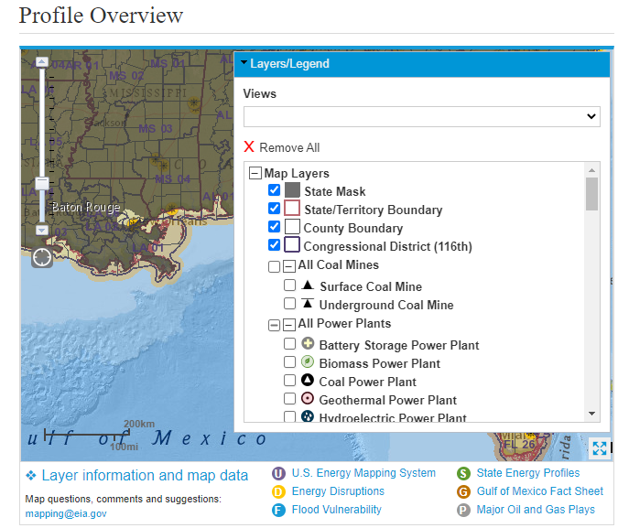

It is my opinion that the quick facts and consumption tab section provide the best source of information. There are tons of valuable data points to prove in our premise or to allocate awareness based around an intent and audiences defined.

# References

eia. (2015). *RESIDENTIAL ENERGY CONSUMPTION SURVEY (RECS)*. Retrieved from eia.gov: https://www.eia.gov/consumption/residential/index.php

fppt. (2020). *Different Types Of Audiences You May Encounter*. Retrieved from fppt.com: https://www.free-power-point-templates.com/articles/different-types-of-audiences-you-may-encounter/

Knaflic, C. N. (2015). *Storytelling with Data: A Data Visualization Guide for Business Professionals.* Wiley.

SmartBug. (2019, 06 10). *The 3 Stages of a Typical Buying Process (i.e., the Buyer’s Journey*. Retrieved from https://www.smartbugmedia.com: https://www.smartbugmedia.com/blog/the-3-stages-of-a-typical-buyers-journey